**Assignment -1**

Python Programming

|  |  |
| --- | --- |
| Assignment Date | 19 September 2022 |
| Student Name | K. Kaviya |
| Student Roll Number | 422319104014 |
| Maximum Marks | 2 Marks |

**Question-1:**

Write a program which will find all such numbers which are divisible by 7 but are not a multiple of 5, between 2000 and 3200 (both included). The numbers obtained should be printed in a comma-separated sequence on a single line.

|  |
| --- |
| **Solution:** |
|  | l=[] |
|  | for i in range(2000, 3201): |
|  | if (i%7==0) and (i%5!=0): |
|  | l.append(str(i)) |
|  |  |
|  | print (','.join(l)) |
|  |  |

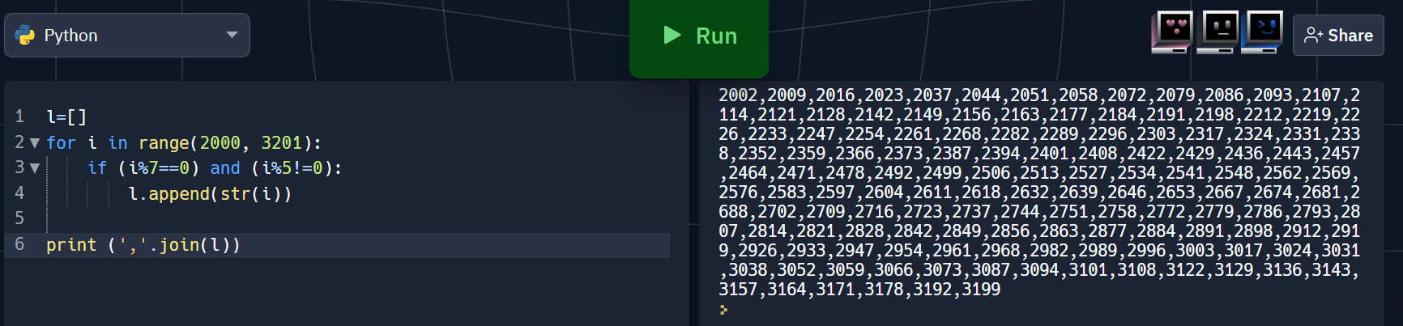

**Question-2:**

With a given integral number n, write a program to generate a dictionary that contains (i, i*i) such that is an integral number between 1 and n (both included). and then the program should print the dictionary.

Suppose the following input is supplied to the program:

8

Then, the output should be:

{1: 1, 2: 4, 3: 9, 4: 16, 5: 25, 6: 36, 7: 49, 8: 64}

|  |
| --- |
| **Solution:** |
|  | n=int(input()) |
|  | d=dict() |
|  | for i in range(1,n+1): |
|  | d[i]=i*i |
|  |  |
|  | print d |
|  |  |

